Name | Asmita Sinha
Roll no | 24204A0027
Batch | 2
Subject name | Python Programming & Data Structure
Teacher Name | Ms. Rasika Patil

Experiments | 9
Title | Develop python program to define class Student with data members (Roll no, Name, Course, Percentage) as input and then print the details.

Programming Questions with Answer
1 | Program to create a Student class and display details
SCRIPT | # Student class definition  class Student:  def __init__(self, roll_no, name, course, percentage):  self.roll_no = roll_no  self.name = name  self.course = course  self.percentage = percentage  def display(self):  print("Roll No:", self.roll_no)  print("Name:", self.name)  print("Course:", self.course)  print("Percentage:", self.percentage)  print("-------------------------")  # List to store student objects  students = []  n = int(input("Enter number of students: "))  for i in range(n):  print("\nEnter details of student", i + 1)  r = int(input("Roll Number: "))  name = input("Name: ")  c = input("Course: ")  p = float(input("Percentage: "))  s = Student(r, nme, c, p)  students.append(s)  # Display all students  print("\n--- Student Details ---")  for s in students:  s.display()
OP | 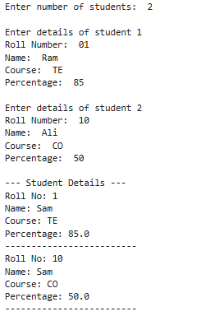
2 | Program using constructor to initialize student details
SCRIPT | class Student:  def __init__(self, name, roll_no, age, course):  self.name = name  self.roll_no = roll_no  self.age = age  self.course = course  def display_details(self):  print("Student Details")  print("Name:", self.name)  print("Roll No:", self.roll_no)  print("Age:", self.age)  print("Course:", self.course)  student1 = Student("DUDE", 26, 17, "Computer Science")  student1.display_details()
OP | 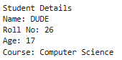
3 | Program to take multiple student objects
SCRIPT | class Student:  def __init__(self, name, roll_no, age, course):  self.name = name  self.roll_no = roll_no  self.age = age  self.course = course  def display(self):  print("Name:", self.name)  print("Roll No:", self.roll_no)  print("Age:", self.age)  print("Course:", self.course)  print("-" * 20)  students = []  n = int(input("Enter number of students: "))  for i in range(n):  print(f"\nEnter details of student {i + 1}")  name = input("Name: ")  roll_no = int(input("Roll No: "))  age = int(input("Age: "))  course = input("Course: ")  student = Student(name, roll_no, age, course)  students.append(student)  print("\nStudent Details")  for student in students:  student.display()
OP | 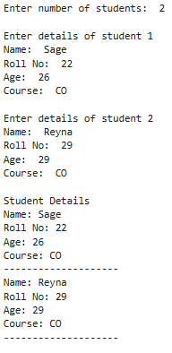
Debugging Questions with Corrected Answers
1 | Debug the following code  Wrong code:  class Student  def __init__(self):  self.name = "Amit"
OP | Error:  SyntaxError: invalid syntax  Correct code:  class Student:  def __init__(self):  self.name = "Amit"
2 | Debug the following code  Wrong code:  class Student:  def show():  print("Hello")  obj = Student()  obj.show()
OP | Error:  TypeError: show() takes 0 positional arguments but 1 was given  Correct code:  class Student:  def show(self):  print("Hello")  obj = Student()  obj.show()
Conclusion | - Object Oriented Programming helps in organizing data using classes and objects  - Constructors (__init__) initialize object data at creation time  - Methods are used to perform operations on object data  - Creating multiple objects allows handling multiple student records efficiently  - This program demonstrates practical use of OOP concepts in Python
Performance Indicators |  | Teachers Dated and Signature
Process Related  (15 M) | Product Related  (10 M) | Total (25 M)

